BLOCKED TO UNRES

Home and 1 more page - Personal - Microsoft​ Edge
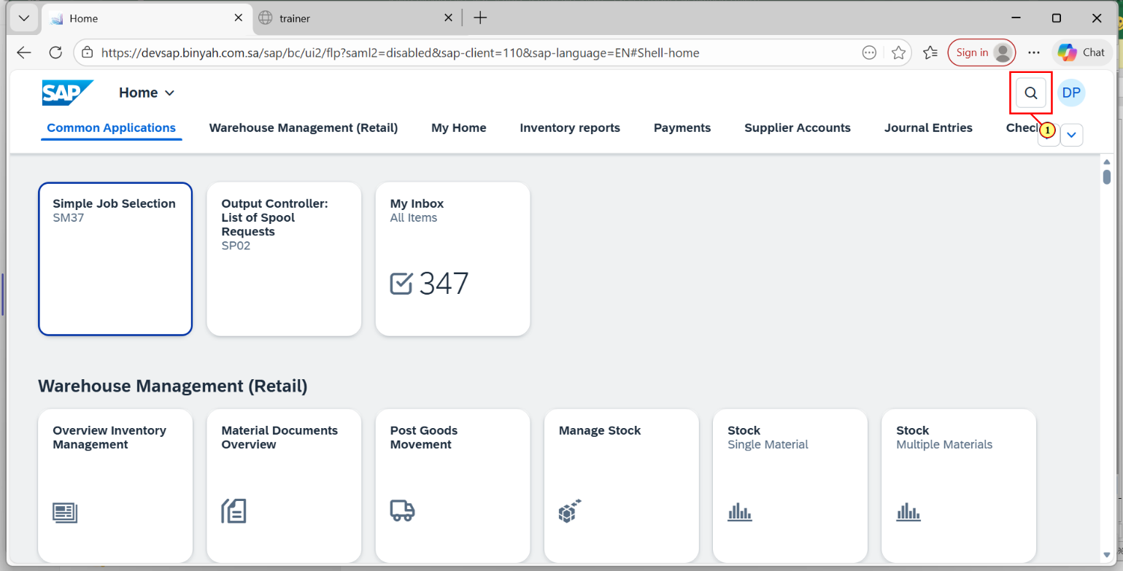
Step | Action
(1) | Click on "Search" Icon.

Home and 1 more page - Personal - Microsoft​ Edge
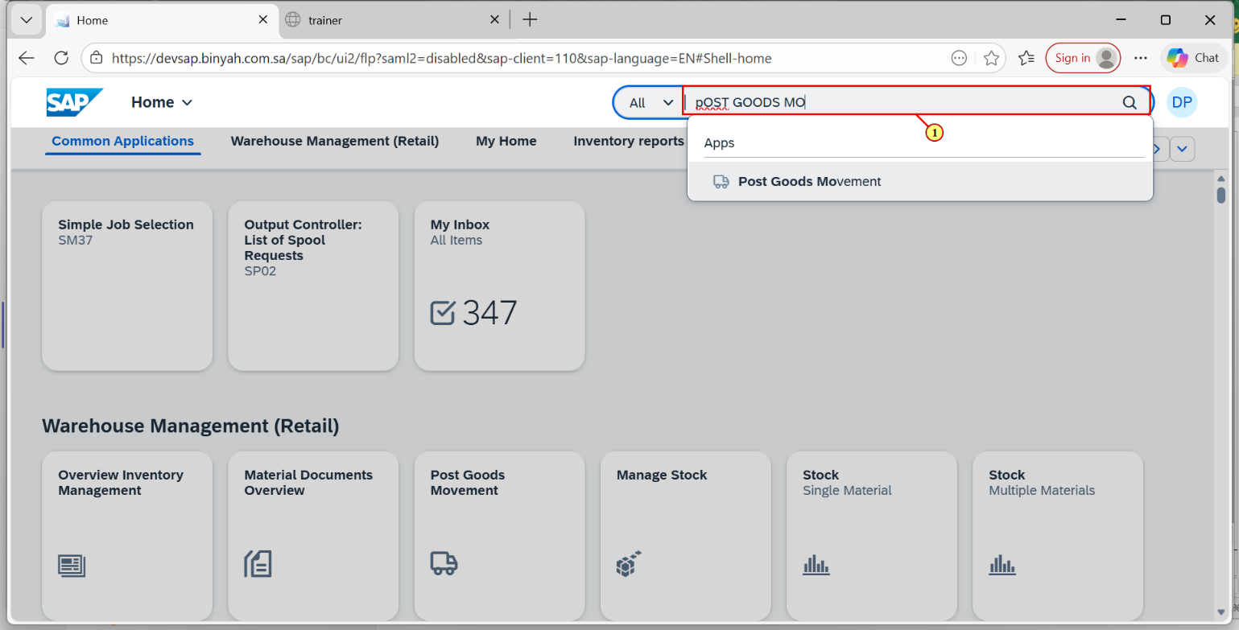
Step | Action
(1) | Search and Open "Post Goods Movement".

Transfer Posting Other and 1 more page - Personal - Microsoft​ Edge
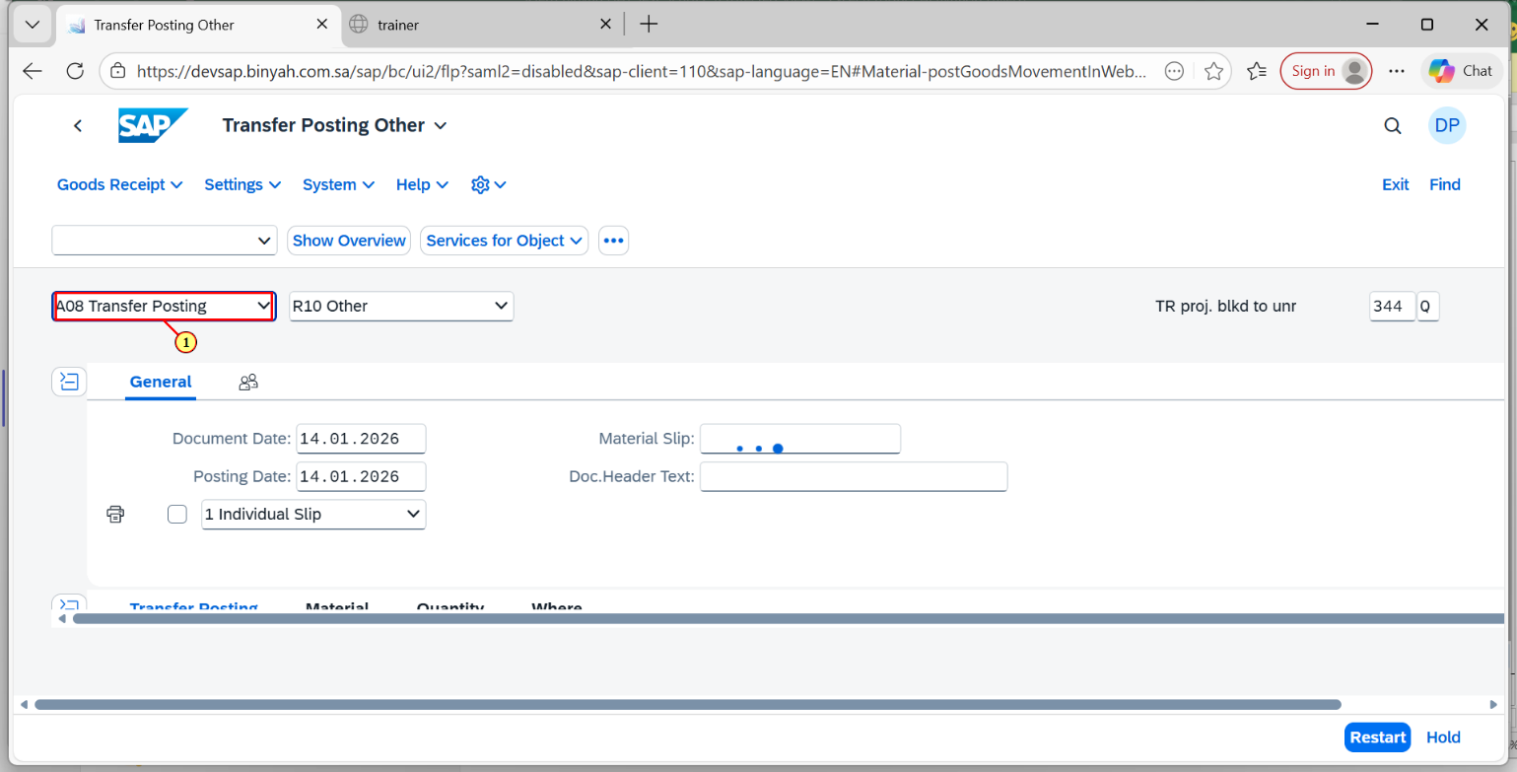
Step | Action
(1) | Select "Transfer Posting".

Transfer Posting Other and 1 more page - Personal - Microsoft​ Edge
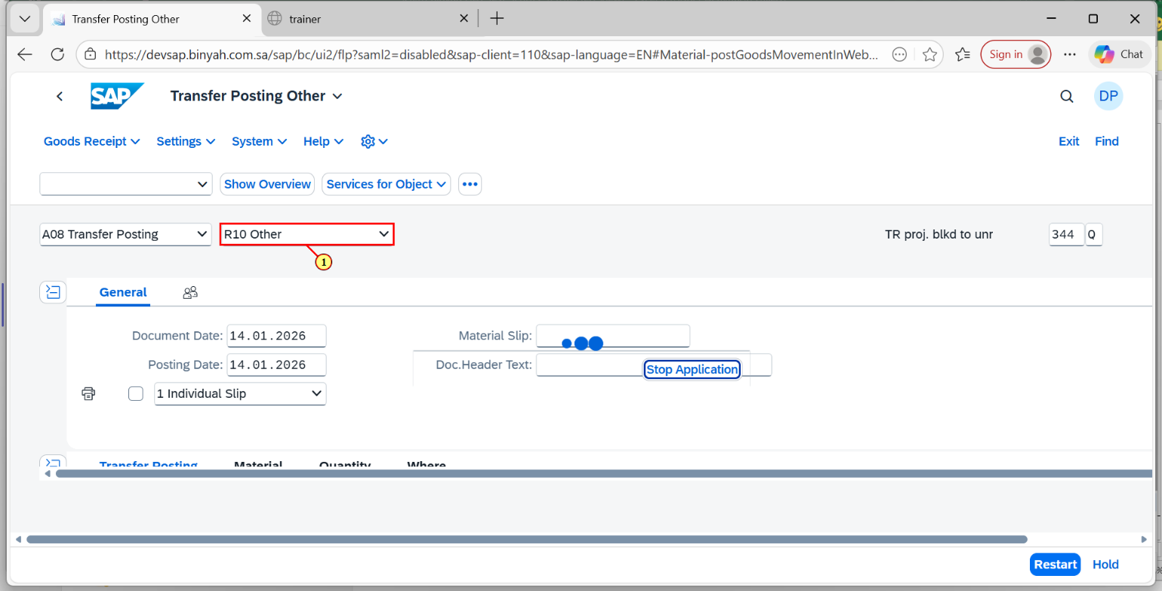
Step | Action
(1) | Select "Other".

Transfer Posting Other and 1 more page - Personal - Microsoft​ Edge
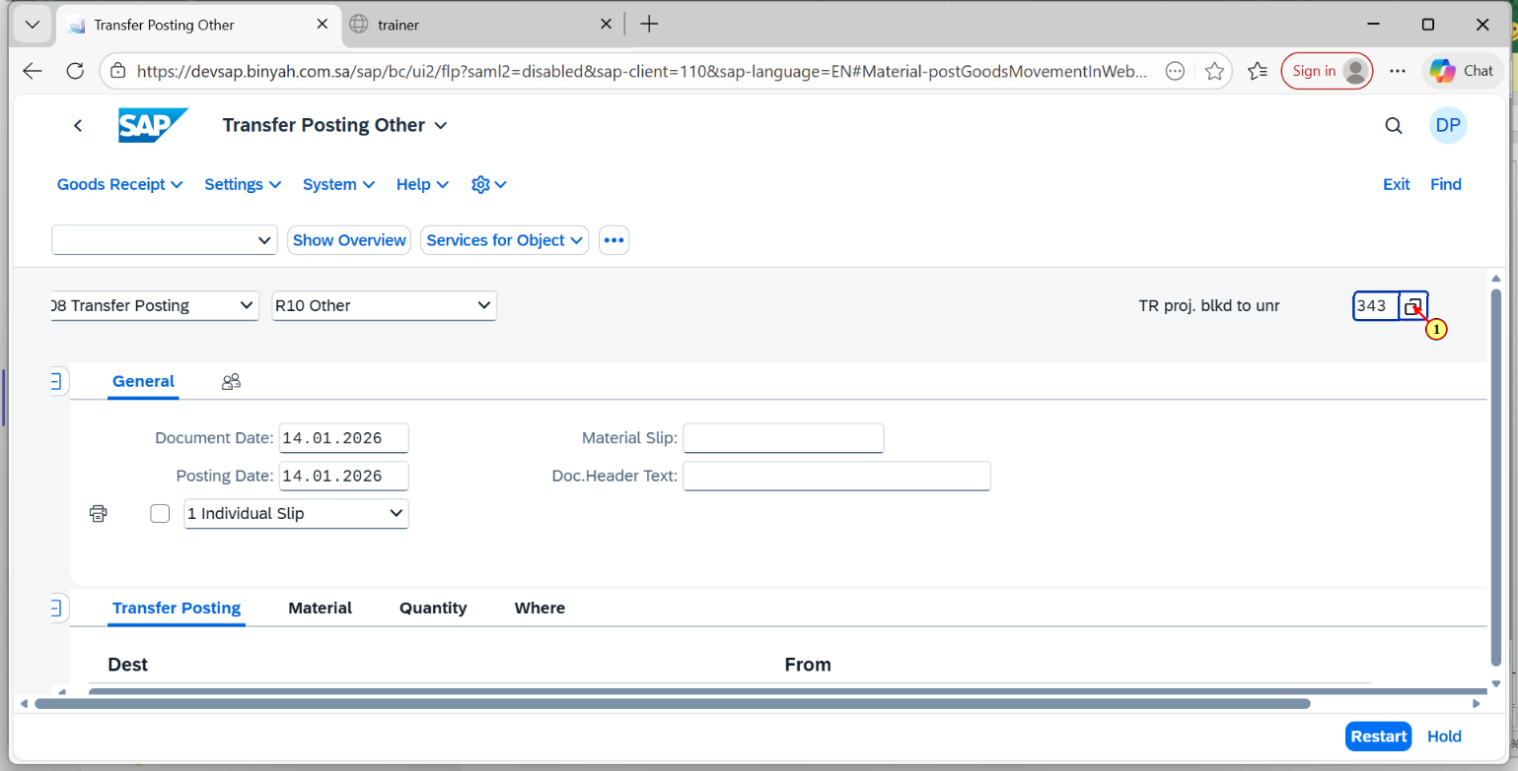
Step | Action
(1) | Select the Movement Type as"343 Q".

Transfer Posting Other and 1 more page - Personal - Microsoft​ Edge
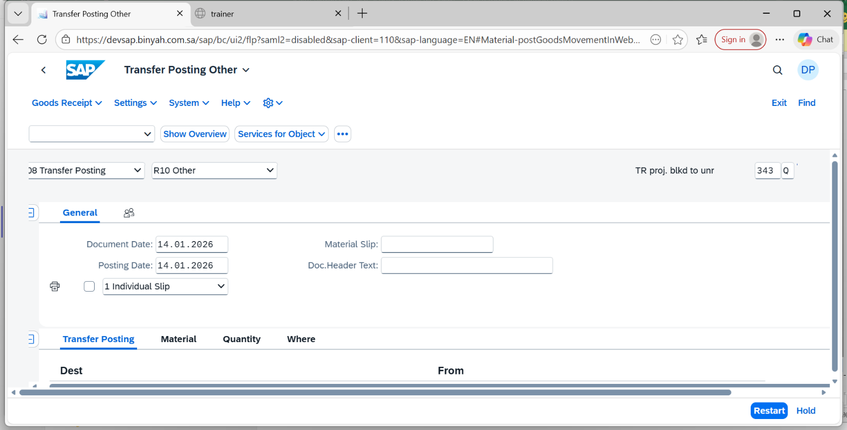
Step | Action
 | Now click "Enter".

Transfer Posting Other and 1 more page - Personal - Microsoft​ Edge
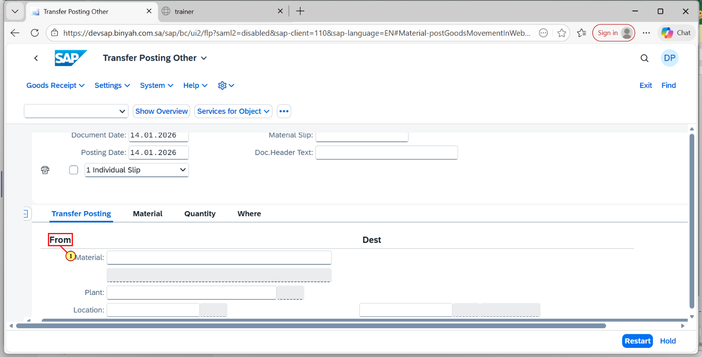
Step | Action
(1) | Click on "From" Section.

Transfer Posting Other and 1 more page - Personal - Microsoft​ Edge
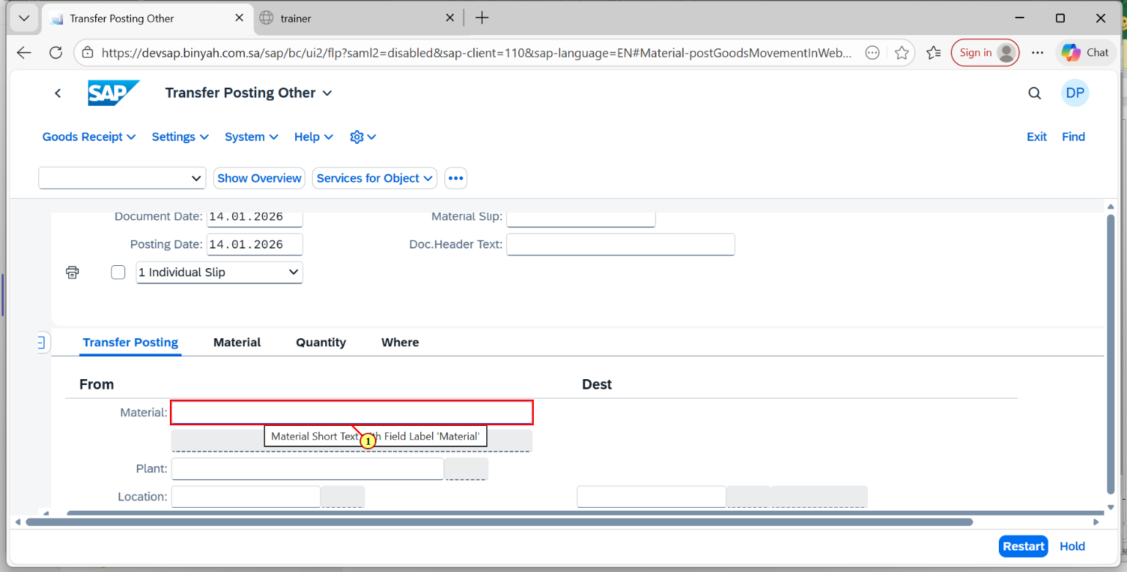
Step | Action
(1) | Enter "Material".

Transfer Posting Other and 1 more page - Personal - Microsoft​ Edge
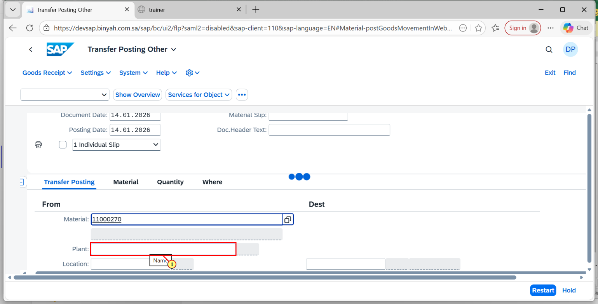
Step | Action
(1) | Enter "Plant".

Transfer Posting Other and 1 more page - Personal - Microsoft​ Edge
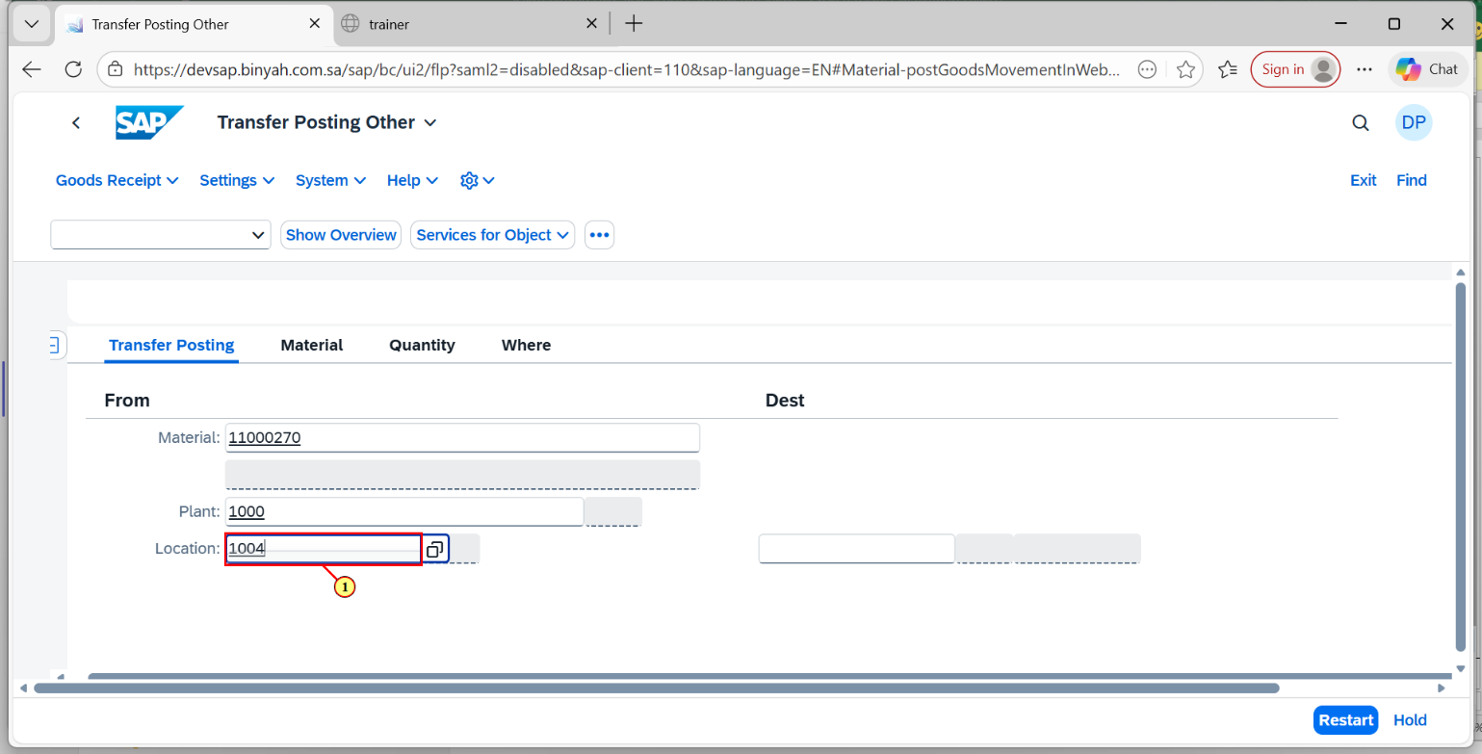
Step | Action
(1) | Enter "Storage Location".

Transfer Posting Other and 1 more page - Personal - Microsoft​ Edge
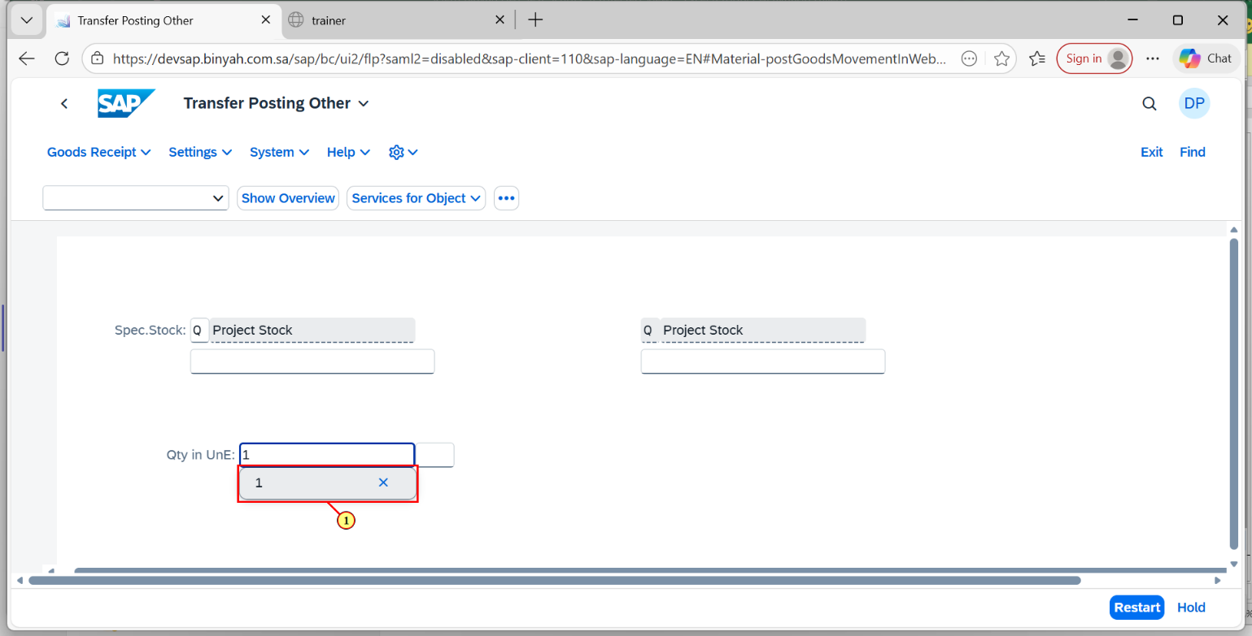
Step | Action
(1) | Enter "Quantity".

Transfer Posting Other and 1 more page - Personal - Microsoft​ Edge
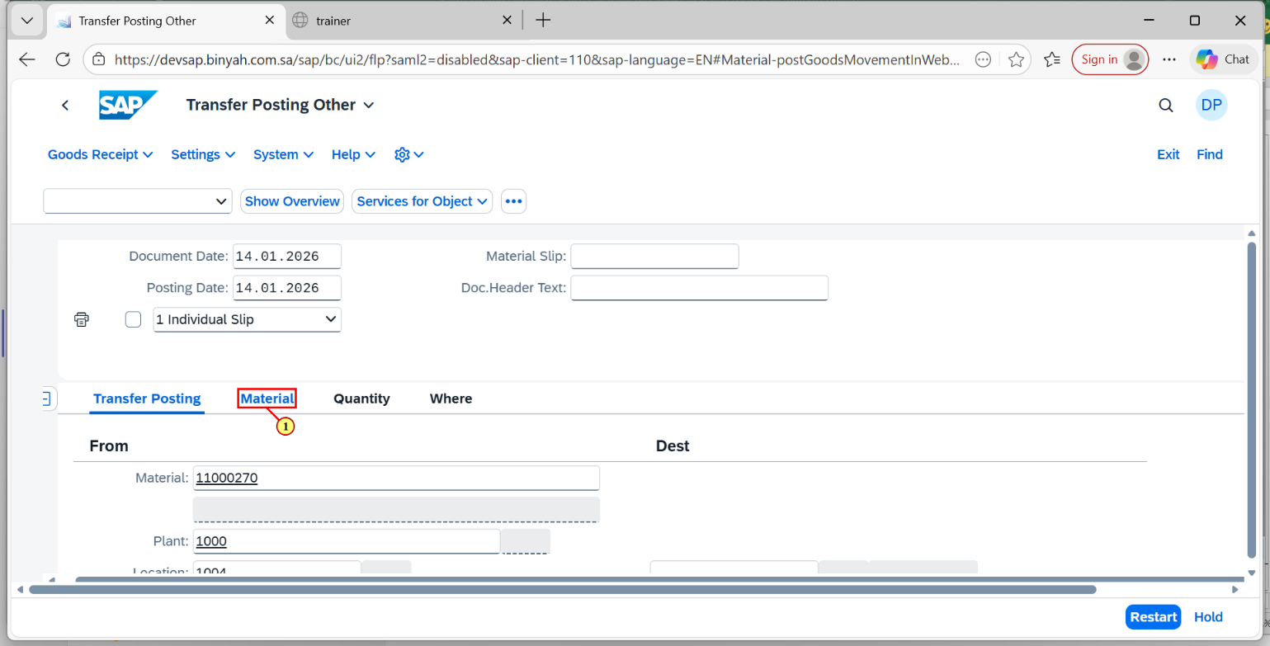
Step | Action
(1) | Click on "Material" Tab.

Transfer Posting Other and 1 more page - Personal - Microsoft​ Edge
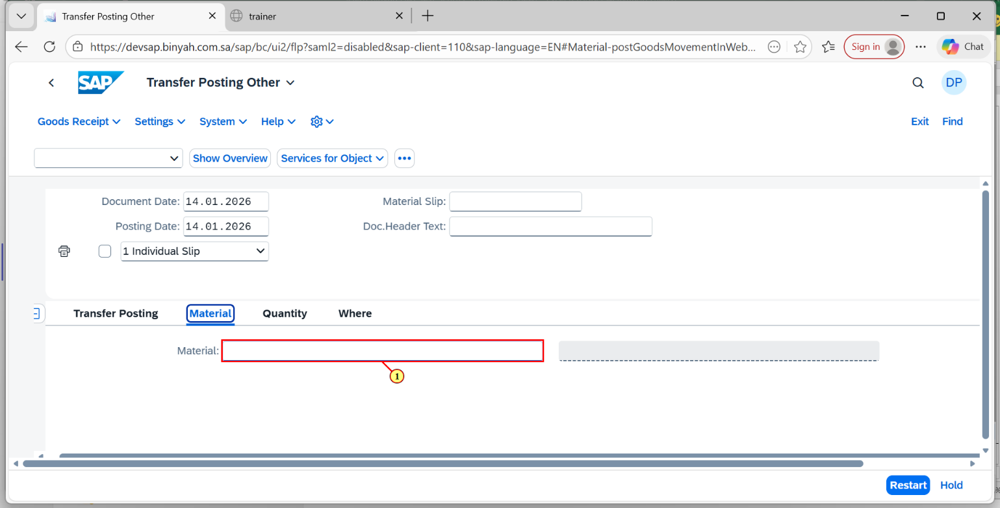
Step | Action
(1) | Enter "Material".

Transfer Posting Other and 1 more page - Personal - Microsoft​ Edge
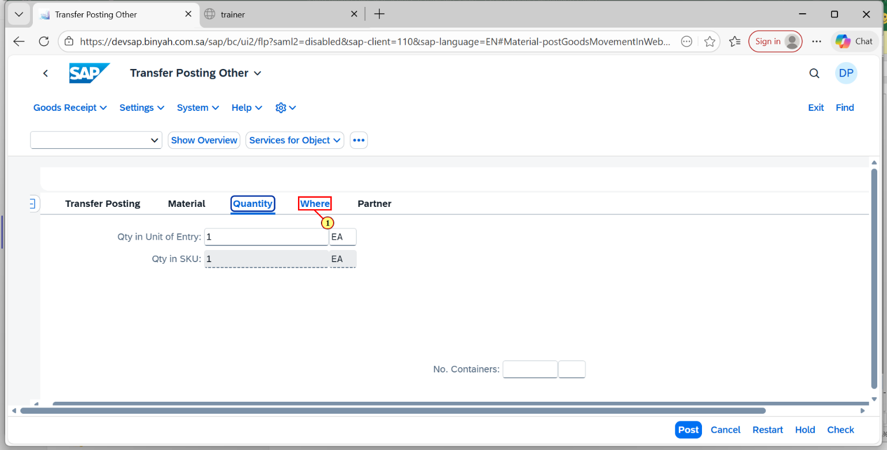
Step | Action
(1) | Click on "Where" Tab.

Transfer Posting Other and 1 more page - Personal - Microsoft​ Edge
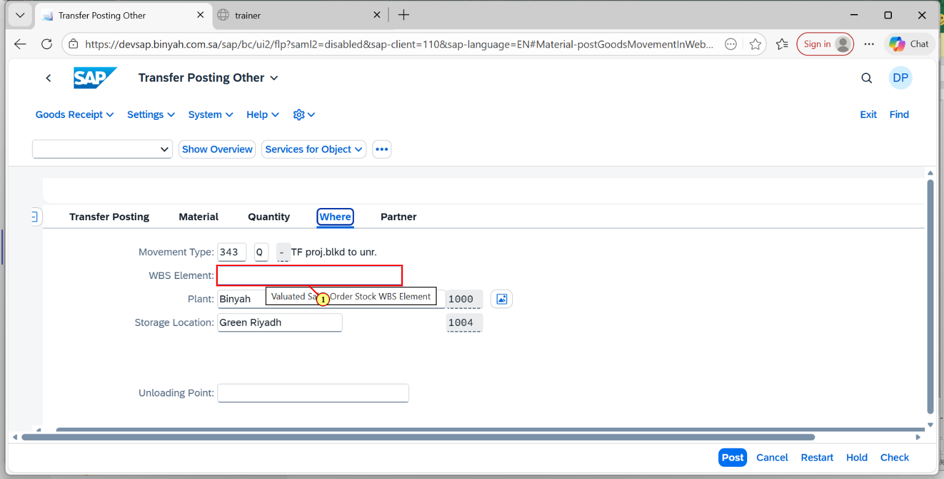
Step | Action
(1) | Enter "WBS Element".

Transfer Posting Other and 1 more page - Personal - Microsoft​ Edge
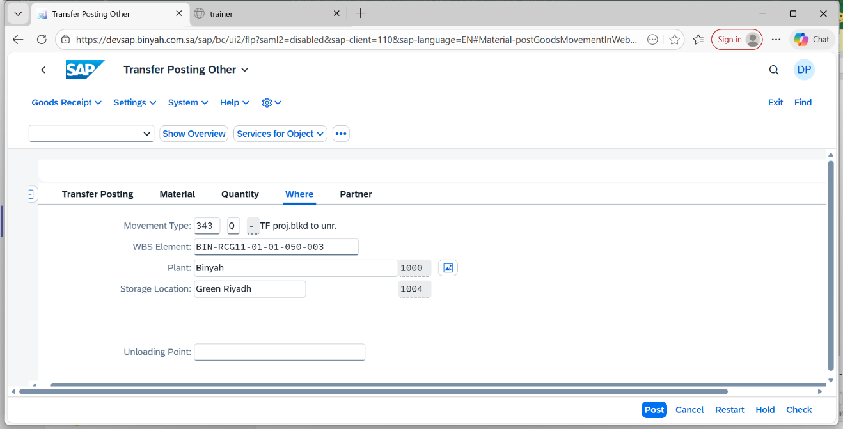
Step | Action
 | Click on "Enter".

Transfer Posting Other and 1 more page - Personal - Microsoft​ Edge
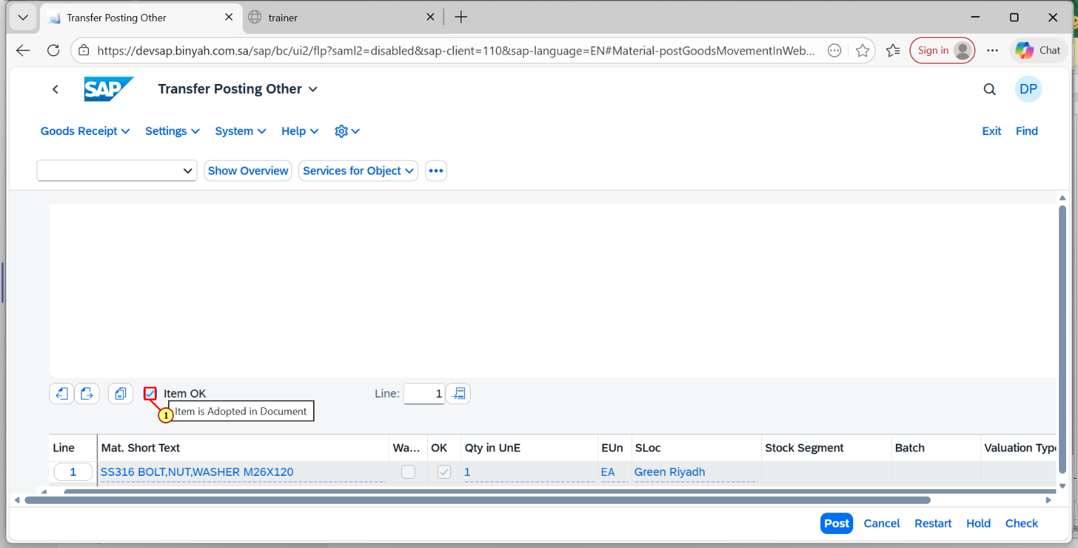
Step | Action
(1) | Click on "Iten ok".

Transfer Posting Other and 1 more page - Personal - Microsoft​ Edge
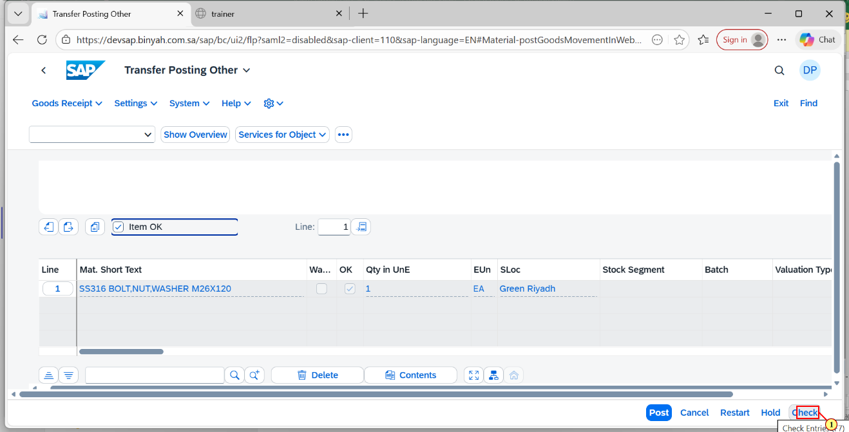
Step | Action
(1) | Click on "Check".

Transfer Posting Other and 1 more page - Personal - Microsoft​ Edge
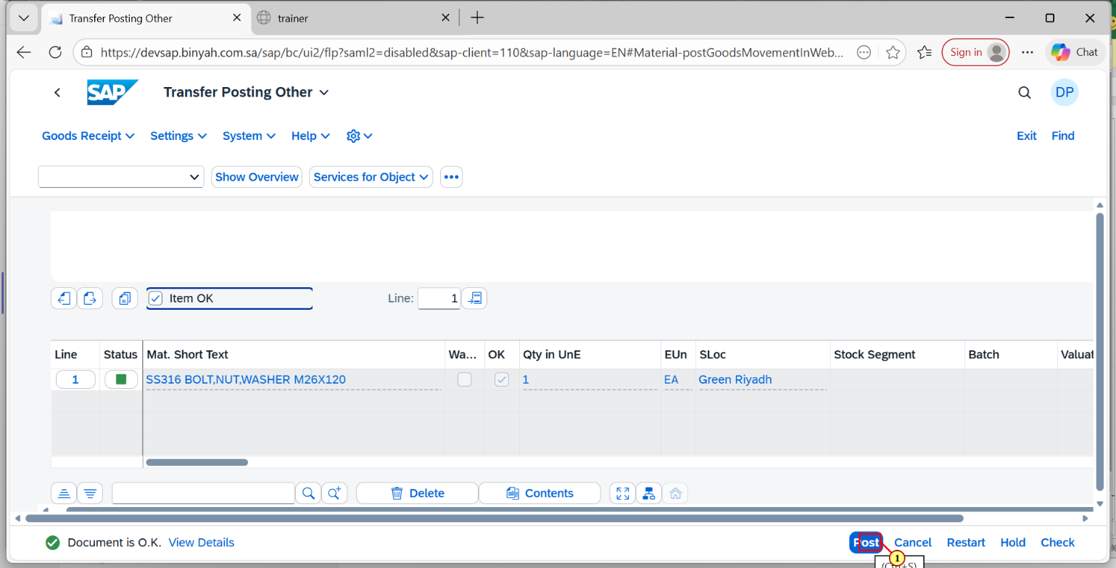
(1) | Click on "Post".

